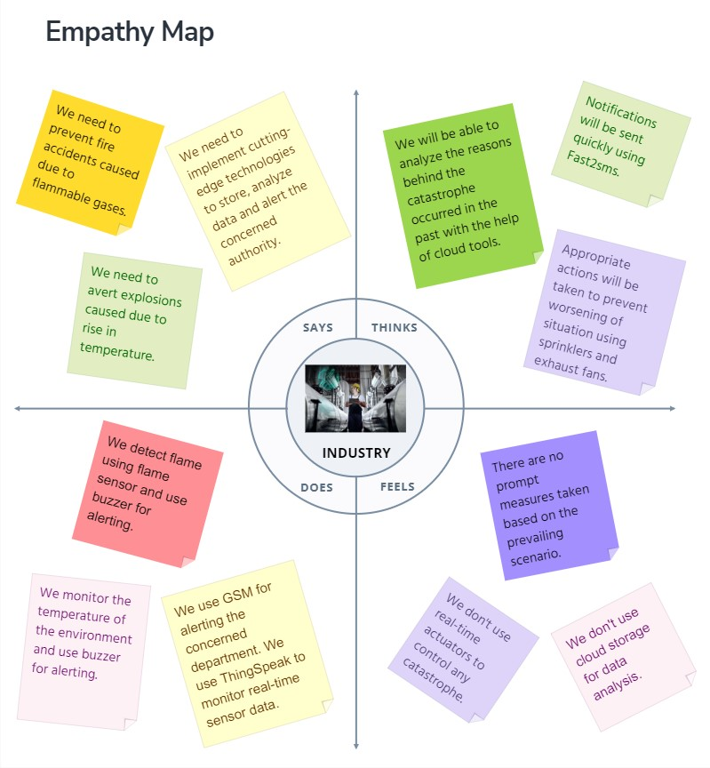**INDUSTRY SPECIFIC FIRE MANAGEMENT SYSTEM**